MON | TUES | WED | THUR | FRI | SAT / SUN
 |  |  |  | 1. | 2.
4. | 5. AUSSIE SLANG   | 6. | 7. YOGA AND STRETCH   | 8. | 9.KURANDA SKYRAIL  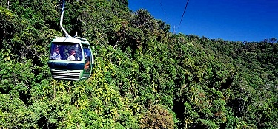
11. | 12. REEF TALK  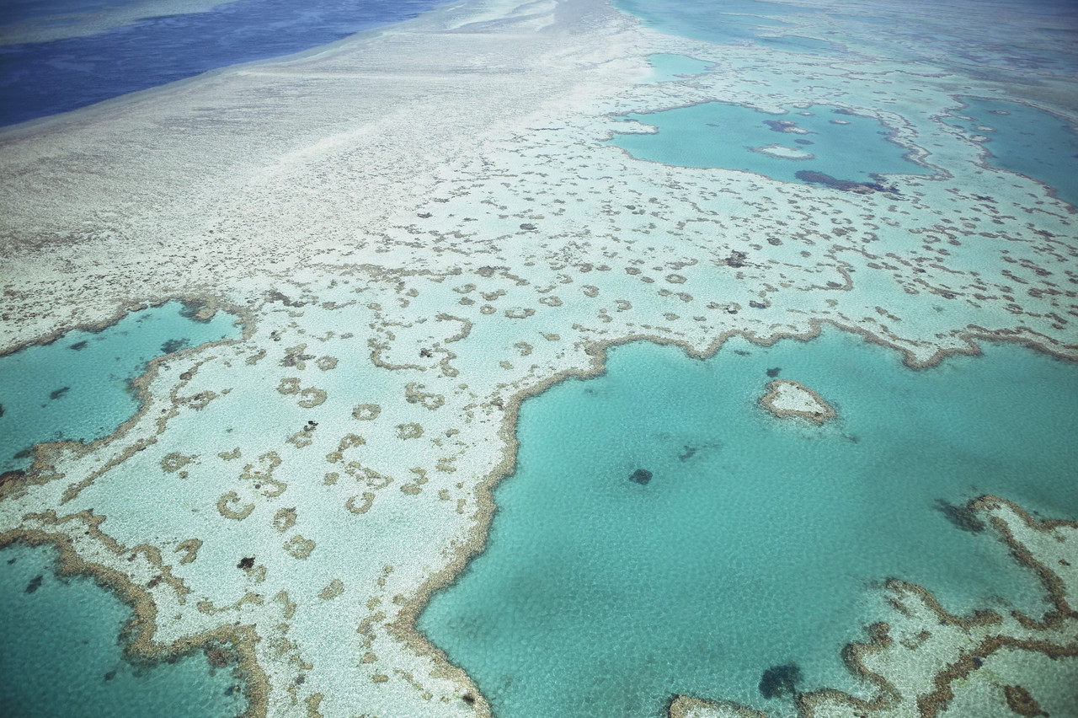 | 13. | 14. SCRABBLE COMPETIION   | 15. | 16.
18. | 19. VOLLEYBALL   | 20. | 21. TABLE TENNIS COMPETITION   | 22. | 23.  FITZROY ISLAND  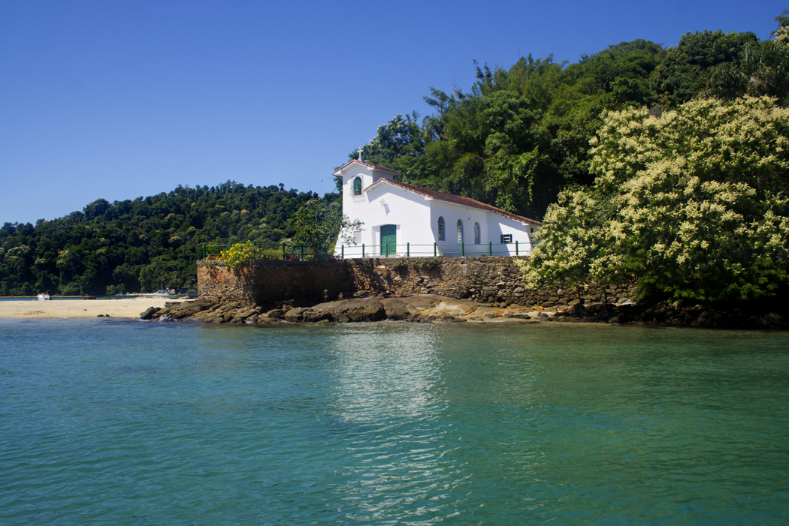
25. | 26. CABLE SKI  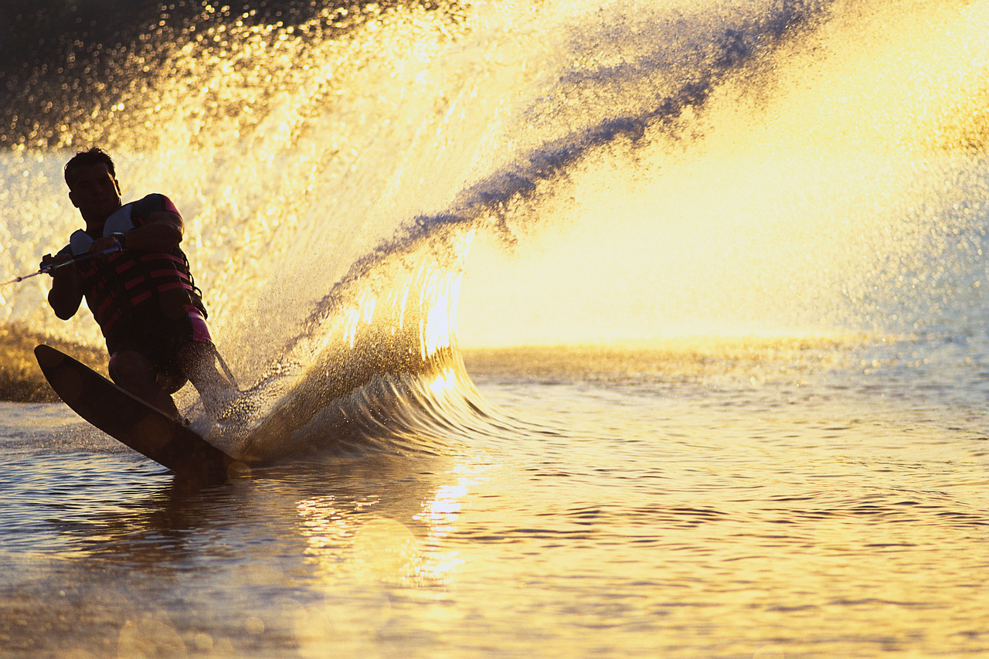 | 27. | 28. AUSSIE  i CHEESE AND WINE TASTING   | 29. | 30

PLEASE SIGN UP FOR ALL ACTIVITIES ON THE SIGN UP SHEETS ON THE ACTIVITIES BOARD IN THE LUNCH ROOM. AFTERNOON ACTIVITIES START AT 3.20 P.M. AND WEEKEND ACTIVITIES TO BE NOTIFIED.

